**Multimedia Information Retrieval**

* Multimedia IRS is the process of satisfying user's stated info by identifying all relevant text, graphics , audio, imagery or video documents from a document collection.

**TREC**

* Any problem related to IRS is solved at TREC (Text Retrieval Conferences). TREC was created by DARPA (Defense Advance Research Projects Agency) and NIST (National Institute of Standards and Technology).
* It provides a set of training documents and a set of test documents, each over 1 Gb in size.
* It was sponsored by DARPA and NIST.
* The metrics defined to evaluate the Information Retrieval System are:
  + Precision
  + Recall
  + Fallout
  + Unique Relevance Recall
* Given a query we need to build an irs, which gives the best results to the user’s interested items from the database.
* In Trec-1, the researchers trying to get their systems to work with large database.
* Trec-2, the researchers performed the first real test of the algorithms and it provided insights in what area to improve their work.
* Trec-3, the participants were experimenting with different techniques for query expansion.
* Trec-4, tried to query the results with shorter queries
* Trec-5, learnt how to evaluate the system and development of evaluation methodologies.

**Measures Used in System Evaluations**

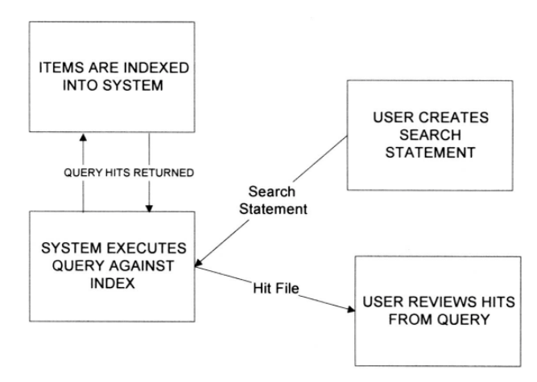

* Measurements can be made from two perspectives: user perspective and system perspective. Techniques for collecting measurements can also be objective or subjective.
* An objective measure is one that is well-defined and based upon numeric values derived from the system operation.
* A subjective measure can produce a number, but is based upon an individual user’s judgments.

Measures used:

1. **Precision**

* It is a measure of the accuracy of the search process.
* It directly evaluates the correlation of the query to the database.
* It is indirectly a measure of the completeness of the indexing algorithm.
* It is a more accurate measure of the use of the user’s time.

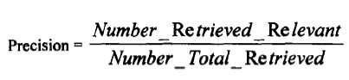

1. **Recall**

* It is a measure of the ability of the search to find all of the “relevant” items that are in the database.
* It is unaffected when “non-relevant” items are retrieved.
* It can be viewed as the probability that a retrieved item is relevant.

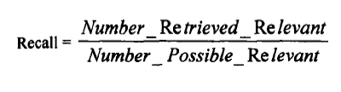

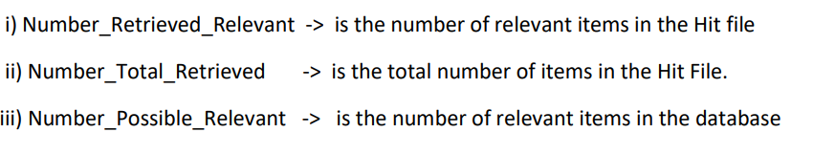

1. Fallout

* It is directly related to retrieving non-relevant items can be used in defining how effective an information system is operating.
* It is used when they are no relevant items in database.
* It can be viewed as the inverse of recall.
* It can be viewed as the probability that a retrieved item is non-relevant.

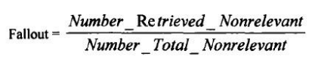

* From a system perspective, the ideal system demonstrates “maximum recall” and “minimum fallout”.
* Of the three measures (precision, recall and fallout), fallout is least sensitive to the accuracy of the search process.

1. Unique Relevance Recall (URR)

* It is used to compare more 2 or more algorithms or systems.
* It measures the no: of relevant items that are retrieved by one algorithm & are not retrieved by the others.

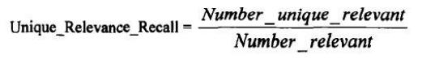

* Here: Number_Unique_Relevant -> is the number of relevant items retrieved that were not retrieved by other algorithms.